Sri Lanka Institute of Information Technology

Internet of Things and Big Data Analytics (IT4021)

Continuous Assignment – 2024, Semester 1

Initial Document

GROUP ID: *2024-06*

Vidanage D.S.D IT21128868

Tennekoon V.L.K IT21015212

Ratnayake B.R.M.P IT21066870

Maddumage P.W IT21007538

Table of Contents

Project description 3

Overall architecture diagram 3

Overall architecture description 4

Methodology 5

Member Contributions 5

List of hardware 7

Cost breakdown 8

References 8

# Project description

Our project aims to design and implement a Smart Home system that automatically manages indoor temperature based on the Heat Index (HI) by manipulating windows. Additionally, we will develop a Node-RED dashboard to visualize current and predicted HI data. The system will incorporate IoT principles, including sensor integration, actuator control, and predictive analytics, to create a comfortable and energy-efficient living environment.

# Overall architecture diagram

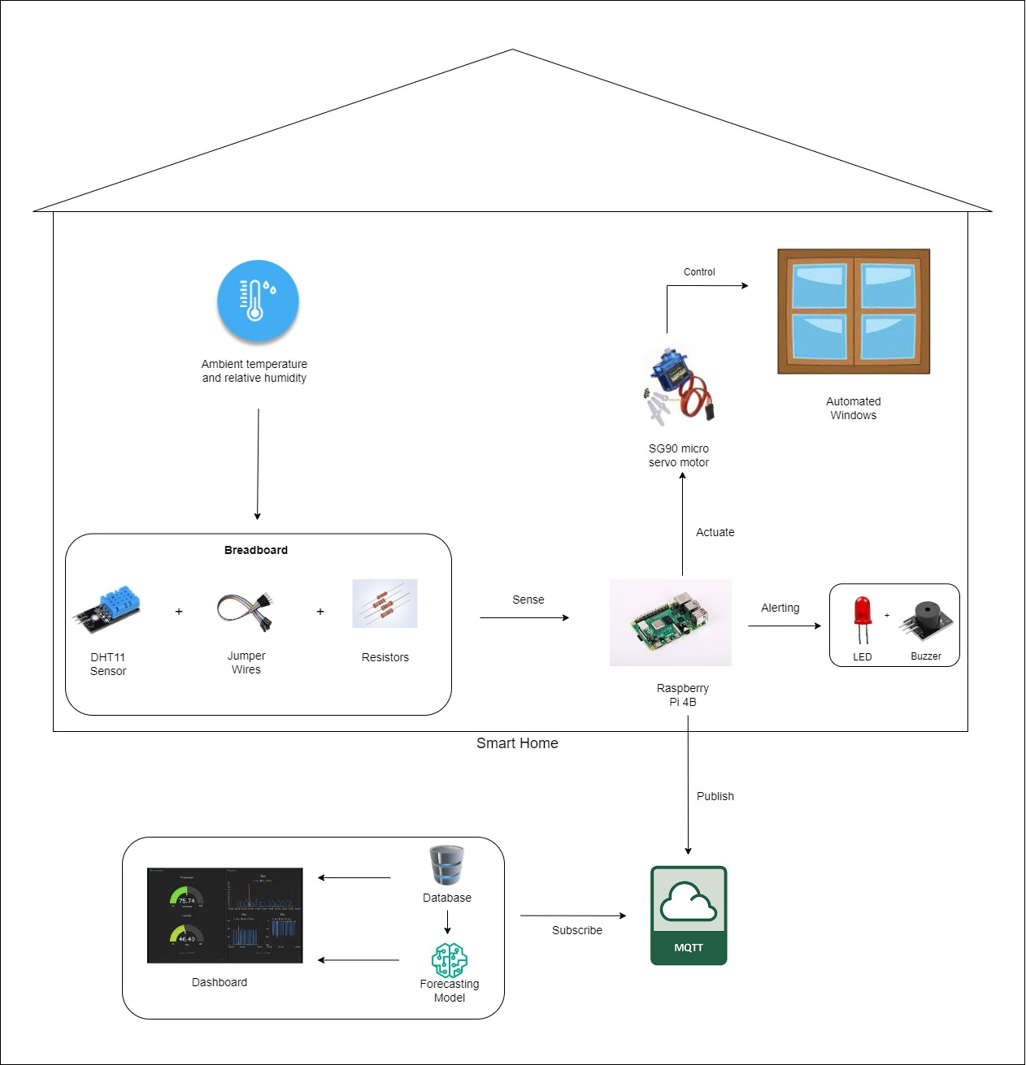

# Overall architecture description

The Smart Home system consists of hardware and software components such as a single board computer (e.g., Raspberry Pi), a temperature and humidity sensor (e.g., DHT11), an actuator (e.g., servo motor), a cloud broker (e.g., MQTT), a NODE RED dashboard, a breadboard, jumper wires, an LED, a buzzer and resistors.

The temperature and humidity sensor is connected to the Raspberry Pi, with the breadboard and jumper wires. The data collected by the sensor is processed inside the Raspberry Pi to calculate the heat index. Then an actuator is connected to the Raspberry Pi through the breadboard using jumper wires and this actuator will open/close the windows of the Smart Home proportionate to the heat index calculated.

The heat index value can be classified in to 5 classes as shown below.

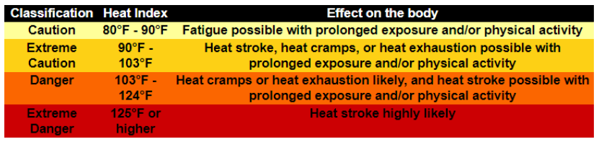

If the heat index is classified as ‘Extreme Danger’, the system notifies this to the user by lighting up an LED and sounding the buzzer connected to the system.

The Raspberry Pi publishes the data in to the cloud broker, MQTT. Then the NODE RED dashboard subscribes to MQTT, receives the data and visualizes in the dashboard. An ARIMA model is built for past and future predictions of heat index. The heat index prediction data and the current heat index data from the sensor readings will be shown in the NODE RED dashboard.

# Methodology

The brain of the Smart Home system is a Raspberry Pi which is a low-cost credit card sized computer with microcontroller functionalities [1]

The inputs for the Smart Home system are temperature and humidity data collected from the DHT11 sensor. DHT11 sensor detects the percentage of the ratio of moisture in the air to the maximum amount that can be held in the air at the current temperature [2]. The collected data can be used to calculate the heat index, which is what the temperature feels like to the human body.

Heat index is calculated as,

HI = -42.379 + 2.04901523*T + 10.14333127*RH - .22475541*T*RH - .00683783*T*T - .05481717*RH*RH + .00122874*T*T*RH + .00085282*T*RH*RH - .00000199*T*T*RH*RH

The heat index calculated can be classified into one of the following classes, caution, extreme caution, danger, and extreme danger. Based on the class of the heat index the actuator will be programmed to open/close the window proportionate to the value of the heat index.

If the heat index is classified as Extreme Danger, the user will be notified via lighting up an LED bulb and sounding a buzzer which are connected to the Raspberry Pi via a breadboard and jumper wires.

The sensor readings are published to the cloud broker and the NODE RED dashboard subscribes to it to receive the data and visualizes it. Node-RED is a free JavaScript-based tool, built on Node.js platform, which provides a visual browser-based flow editor [3] MQTT nodes in Node-RED platform allow the dashboard to stay connected with the MQTT server [4]

The predictions of the heat index for the past 12 months and for the upcoming 12 months will be predicted using an ARIMA model which is a statistical method used for time series forecasting. Autoregressive integrated moving average (ARIMA) models are amongst the most used time-series models in existence [5]. These predictions will also be visualized in the NODE RED dashboard.

# Member Contributions

Vidanage D.S.D - IT21128868

This component mainly focuses on integrating the DHT11 sensor with the Raspberry Pi to collect temperature and humidity data, which serves as vital input for the Smart Home system. The task involves developing code to calculate the heat index using the collected sensor data, employing the specified formula. Additionally, programming the actuator to control the window based on the classified heat index is within the scope of this component. Ensuring seamless communication between the sensor, Raspberry Pi, and actuator contributes to the efficient operation of the Smart Home system.

Tennekoon V.L.K - IT21015212

This component primarily focuses on hardware assembly and system integration to enable the Smart Home system to respond effectively to the calculated heat index. Assembling the necessary components, including the DHT11 sensor and the actuator for window control, within the cardboard model smart home is the primary task. Securely mounting the Raspberry Pi and connecting all hardware components to ensure proper functionality is also part of this component's responsibility. Exploring alternative window movement simulation techniques to enhance the user experience within the prototype is another aspect.

Ratnayake B.R.M.P - IT21066870

This component primarily focuses on implementing LED and buzzer control, along with dashboard development, to enhance user interaction and visualization within the Smart Home system. Designing circuits to connect the LED and buzzer to the Raspberry Pi and developing code to activate them based on the classified heat index are key tasks. Additionally, utilizing Node-RED to create a dashboard displaying real-time sensor data and displaying the calculated heat index contributes to a comprehensive understanding of environmental conditions within the prototype.

Maddumage P.W - IT21007538

This component mainly focuses on dashboard development and code quality to ensure effective visualization and interpretation of sensor data within the Smart Home system. Utilizing Node-RED to create a user-friendly dashboard that displays predictions of the heat index for the past and upcoming 12 months, generated using the ARIMA model, is the key task. Configuring the dashboard to subscribe to sensor data published to the cloud broker ensures seamless integration with the rest of the system. Prioritizing clean and well-commented code enhances the usability and reliability of the dashboard component within the Smart Home prototype.

# List of hardware

Here are the descriptions of the components and their roles in the smart home system:

1. Sensor - Digital Temperature and Humidity Sensor Module (DHT11)

DHT11 sensor is a basic digital temperature and humidity sensor module which has the ability to measure temperatures ranging from 0°C to 50°C with an accuracy of ±2°C and relative humidity ranging from 20% to 90% with an accuracy of ±5%. In the smart home system, the DHT11 sensor will be used to sense the ambient temperature and humidity inside the home. It will provide data to the Raspberry Pi for monitoring the internal conditions and calculating the Heat Index.

2. Actuator - Servo Motor SG90 (Actuator for Window Control):

The SG90 servo motor is a small, lightweight motor with precise control capability. It is commonly used in hobbyist projects and small-scale automation applications. In the smart home system, the SG90 servo motor will act as the actuator to control the opening and closing of the windows accordingly. The Raspberry Pi will send control signals to the servo motor to open or close the windows based on the heat index readings. The position of the servo motor will be adjusted based on the received MQTT messages which contains the calculated Heat Index data, allowing for proportional control of the window position.

3. Microcomputer - Raspberry Pi 4B Model:

The Raspberry Pi is a small, single-board computer developed by the Raspberry Pi Foundation with built-in Wi-Fi, Bluetooth, and GPIO (General Purpose Input/Output) pins. It runs a Linux-based operating system (such as Raspbian) and is popular for IoT projects due to its versatility and community support. It features a powerful ARM-based processor, RAM, USB ports, HDMI output, GPIO pins, and more. In this system, the Raspberry Pi will serve as the main controller, handling data processing, communication with sensors and actuators, and running the Node-RED dashboard. It receives the sensor data from the DHT11 sensor, controls the SG90 servo motor to adjust window positions, and communicates with the MQTT broker to publish and subscribe to messages.

4. Micro SD Card:

This is the primary storage medium for the Raspberry Pi, which stores the Raspberry Pi OS. It enables the Raspberry Pi to run applications and store the sensor readings and other necessary data and information. The software installed SD card is inserted into the Raspberry Pi microcomputer.

5. Alert related Components:

LED Bulb - A visual indicator to alert occupants of extreme Heat Index levels.

6. 3.3 to 5V Active Buzzer Alarm Module Sensor: - To provide an audible alert in case of emergency situations, such as fire or gas leaks.

6. Other Components:

Breadboard - A platform for connecting sensors, actuators, and other electronic modules.

Jumper wires - To establish electrical connections between components on the breadboard.

Resistors - To limit current flow or voltage levels as needed.

LAN Cable - To connect the Raspberry Pi to the local network or internet for data communication

# Cost breakdown

|  |  |
| --- | --- |
| **Component** | **Price (LKR.)** |
| DHT11 Sensor | 240.00 |
| Servo Motor SG90 | 340.00 |
| Raspberry Pi 4B Model | 37,800.00 |
| Micro SD Card 32 GB | 2,220.00 |
| LED Bulb | 5.00 |
| 3.3 to 5V Active Buzzer Alarm Module Sensor | 140.00 |
| Breadboard | 140.00 |
| Jumper wires | 170.00 |
| Resistors | 60.00 |
| LAN Cable | 355.00 |
| **Total** | **41,470.00** |

# References

[1] Venkatesh, K., Rajkumar, P., Hemaswathi, S. and Rajalingam, B., ‘IoT based home automation using raspberry Pi”. 2018 *J. Adv. Res. Dyn. Control Syst*, *10*(7), pp.1721-1728.

[2] J. Parmar, T. Nagda, P. Palav and H. Lopes, "IOT Based Weather Intelligence," 2018 International Conference on Smart City and Emerging Technology (ICSCET), Mumbai, India, 2018, pp. 1-4, doi: 10.1109/ICSCET.2018.8537382. keywords: {Temperature sensors;Monitoring;Temperature measurement;Wireless fidelity;Humidity;Node MCU Wifi Arduino;Temperature;Humidity;Noise;CO;Rain gauge;Geo-Tagging},

[3] M. Lekić and G. Gardašević, "IoT sensor integration to Node-RED platform," 2018 17th International Symposium INFOTEH-JAHORINA (INFOTEH), East Sarajevo, Bosnia and Herzegovina, 2018, pp. 1-5, doi: 10.1109/INFOTEH.2018.8345544. keywords: {Cloud computing;Internet of Things;Tools;Servers;Pins;Operating systems;IoT;Node-RED;DHT11 sensor;Raspberry Pi},

[4] R. K. Kodali and A. Anjum, "IoT Based HOME AUTOMATION Using Node-RED," 2018 Second International Conference on Green Computing and Internet of Things (ICGCIoT), Bangalore, India, 2018, pp. 386-390, doi: 10.1109/ICGCIoT.2018.8753085. keywords: {NodeMCU;Node-RED;IoT;Home Automation;MQTT},

[5] S. McDonald, S. Coleman, T. M. McGinnity and Y. Li, "A hybrid forecasting approach using ARIMA models and self-organising fuzzy neural networks for capital markets," The 2013 International Joint Conference on Neural Networks (IJCNN), Dallas, TX, USA, 2013, pp. 1-7, doi: 10.1109/IJCNN.2013.6706965. keywords: {Predictive models;Neurons;Data models;Biological system modeling;Computational modeling;Fuzzy neural networks;Forecasting},